AWS Lambda & Step Function
Task 1
To create a Lambda function AWS Lambda console → Create function was opened. The "Author from scratch" option was selected rather than a blueprint or a container image, since the task only required a simple function to demonstrate JSON parsing and did not need any pre-built template or containerized deployment. This was the fastest and most transparent way to get a working function with full control over the code.
For the function name, volha_bolatava_json_parser was used. For the runtime, Python 3.14 was selected, since Python is well suited for quick scripting tasks like parsing JSON and printing values to logs. By default, AWS Lambda automatically created an execution role for the function with permissions to write logs to Amazon CloudWatch, which was left as-is since no additional permissions were needed for this simple use case. After confirming these settings, "Create function" was clicked.
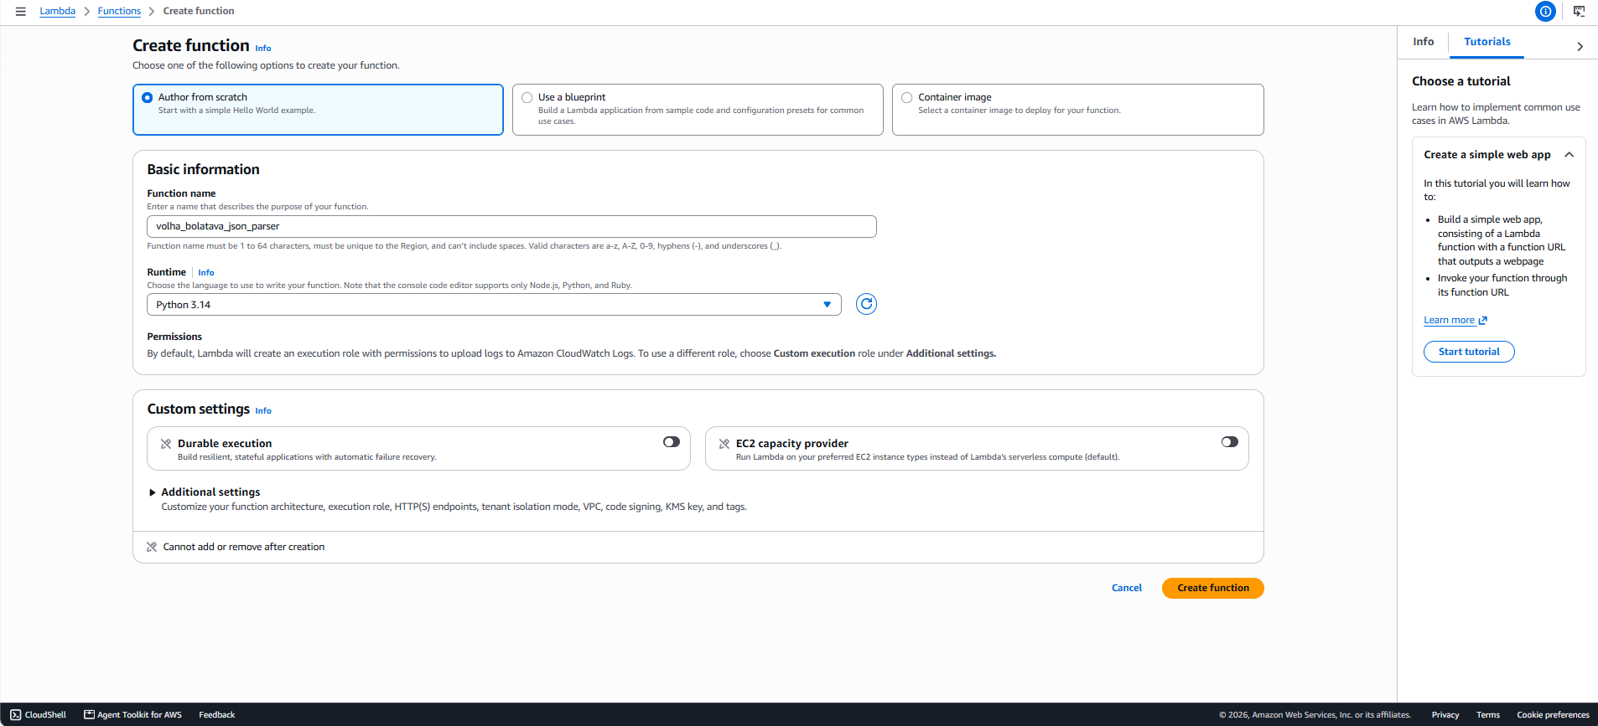
Once the function was created, the built-in code editor (Code source) was opened to write the logic:
import json
def lambda_handler(event, context):
# Extract values from the incoming JSON payload (event)
key1 = event.get('key1', '')
key2 = event.get('key2', '')
key3 = event.get('key3', '')
# Log values to CloudWatch / Function Logs
print(f"Value for the key key1 is - {key1}")
print(f"Value for the key key2 is - {key2}")
print(f"Value for the key key3 is - {key3}")
# Return the response formatted as JSON
return {
"key1": key1,
"key2": key2,
"key3": key3
}
The function is defined through the standard lambda_handler(event, context) entry point, which AWS Lambda invokes automatically when the function runs, passing the incoming payload as event.
Inside the handler, three values were extracted from the incoming JSON event using event.get('key1', ''), event.get('key2', ''), and event.get('key3', ''). Using .get() with a default empty string was a deliberate choice to avoid the function crashing with a KeyError if one of the keys happened to be missing from the input — this makes the function more robust to slightly malformed or incomplete test input.
After extracting the values, print() statements were added to log each key's value. This was done specifically so the parsed values would be visible in the Function Logs section of the test output. Finally, the function returns a dictionary containing key1, key2, and key3 with their corresponding parsed values. Returning this data (in addition to logging it) makes the parsing result visible in two places: the function's direct response output and the logs — giving a more complete demonstration of what the function did with the input.
After the code was written, "Deploy" was clicked to save and activate the new version of the function code, and the console confirmed with "Successfully updated the function."

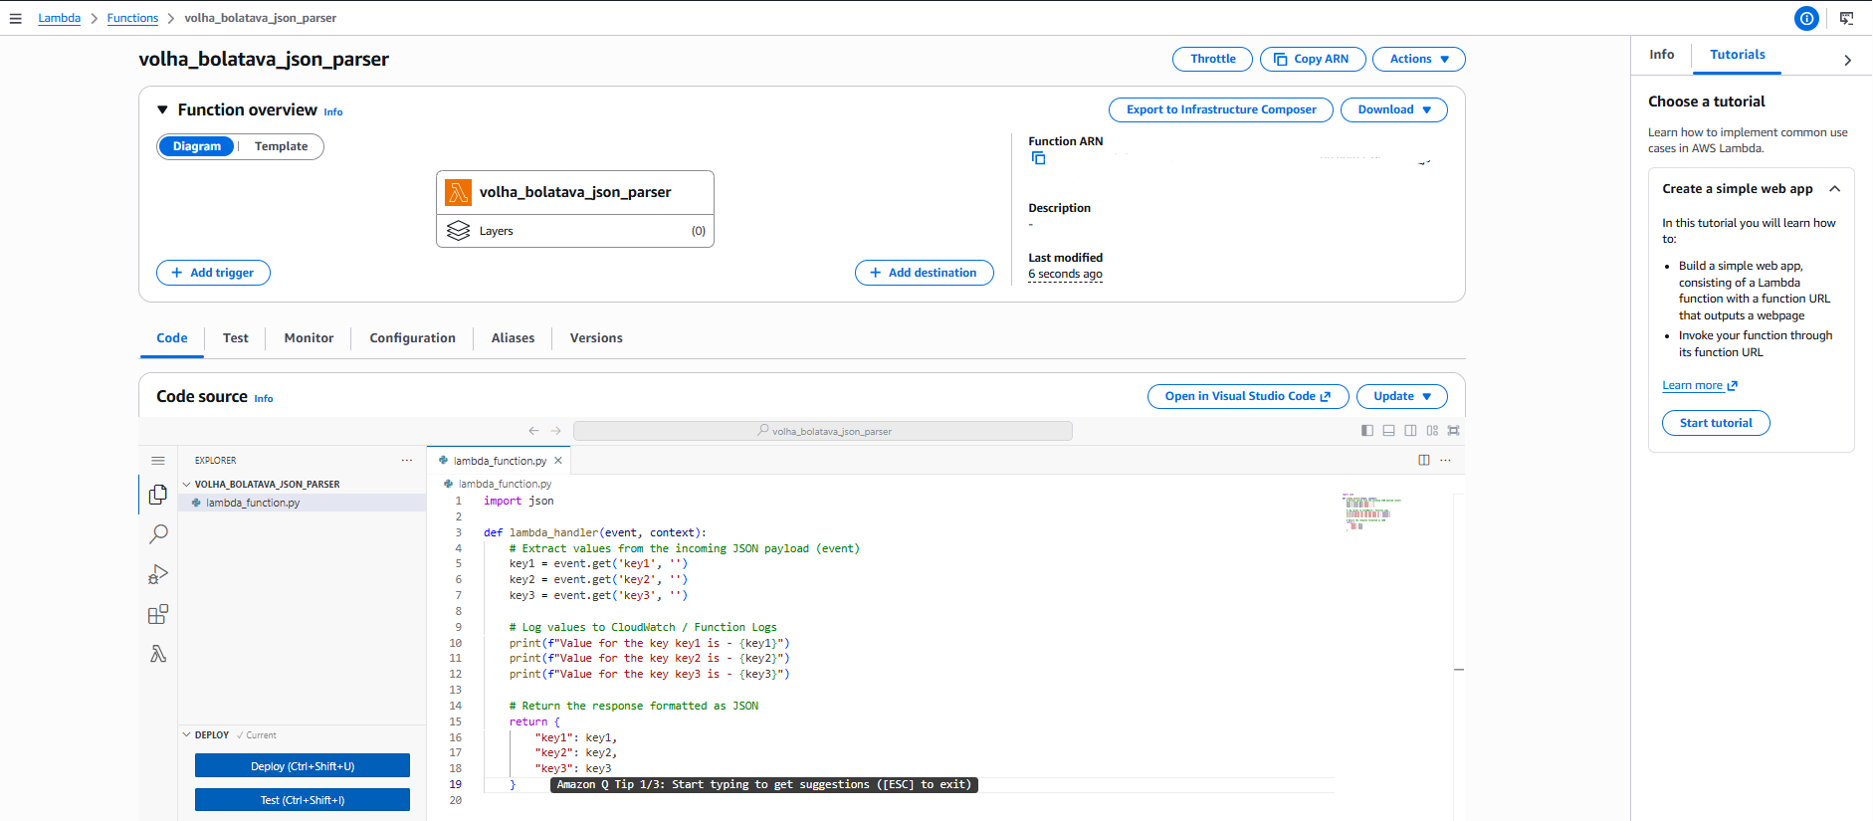
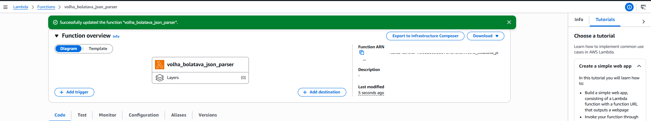
To verify the function worked correctly, a new test event named test_json was created. The "Hello World" template was used as a starting point (since it already provides a simple key-value JSON structure), and the Event JSON was edited to:
{ "key1": "value1", "key2": "value2", "key3": "value3" }
The invocation type was set to Synchronous, since the result needed to be visible immediately rather than just returning a request ID. The event was also marked as "Shareable" rather than "Private" so that it would remain available to other IAM users in the same account, in case the test needed to be reused or reviewed by someone else.
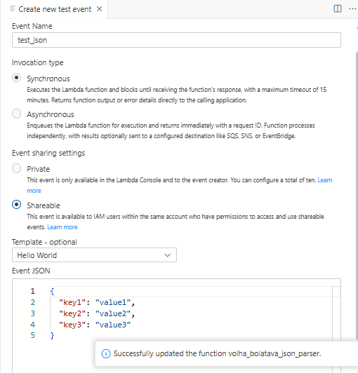
After the test event was saved, "Test" was clicked to invoke the function with this JSON input. The execution result confirmed Status: Succeeded, meaning the function ran without errors.
In the Response section, the returned JSON matched exactly what was sent in — key1: value1, key2: value2, key3: value3 — confirming that the event.get() calls correctly extracted each key's value from the input and that the return statement correctly formatted it back into JSON.

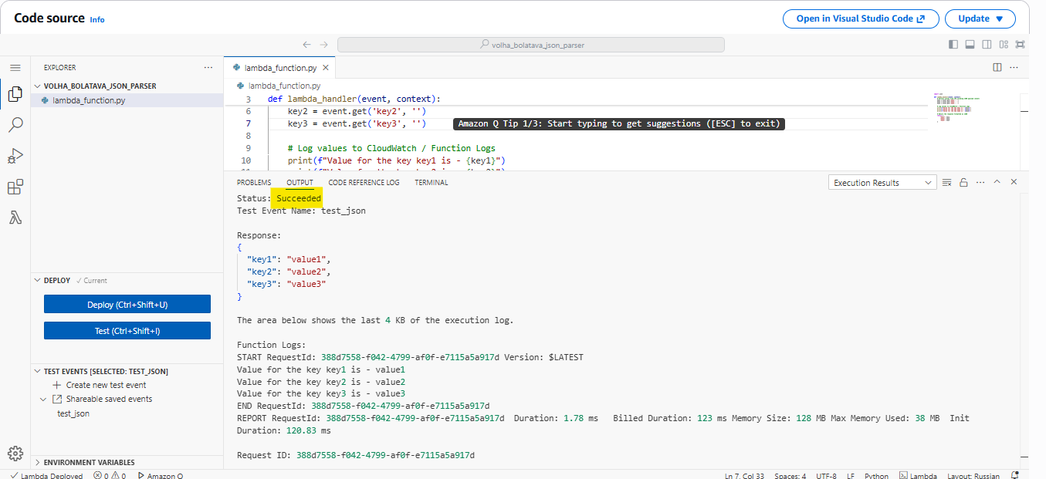
In the Function Logs section, the three print() statements confirmed the same values were logged during execution (e.g., "Value for the key key1 is - value1"), along with execution metadata such as Request ID, Duration (1.78 ms), Billed Duration (123 ms), and Memory Used (38 MB). This log output directly demonstrates that the JSON parsing happened as expected and is traceable through CloudWatch-style function logs, fulfilling the task's requirement.
Task 2
A new security group named lambda-redshift-sg was created in the same VPC as the Redshift cluster, with the description "Allows SSH access to developers." No inbound rules were added at creation time, since the security group's initial purpose was only to define outbound access; an outbound rule was added allowing all traffic to the current IP address under "My IP" as the destination. This setup was intended to control both directions of traffic tied to this security group before it was attached to the Lambda function.
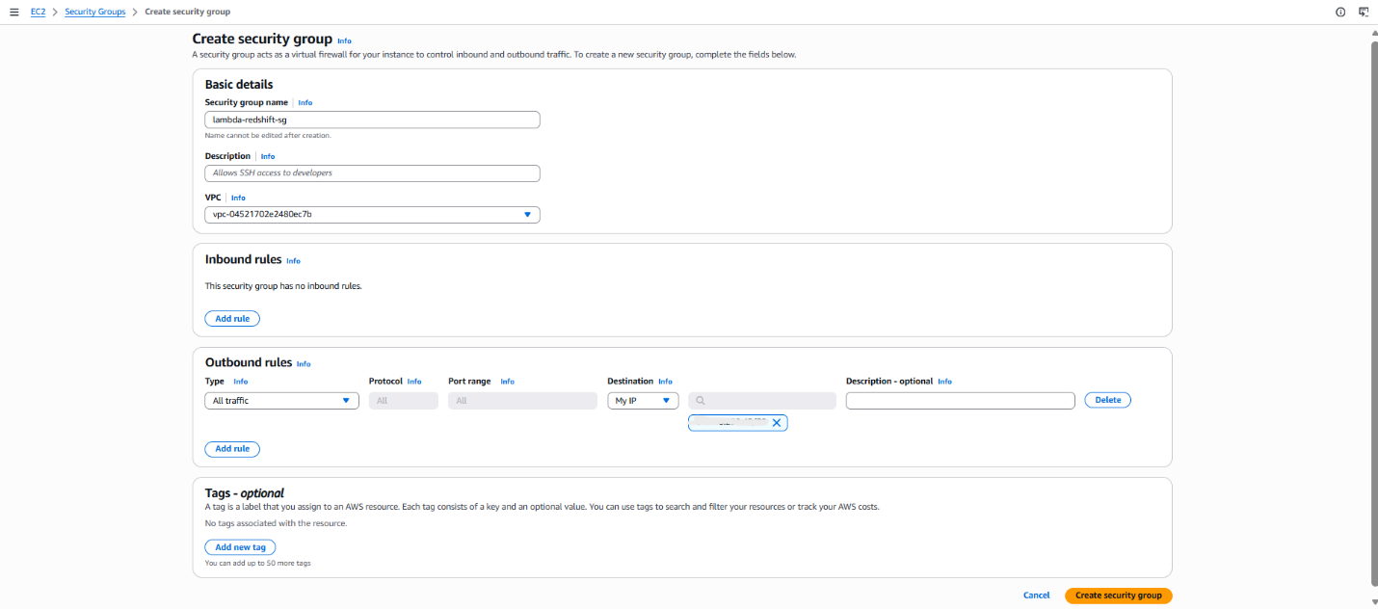
Afterward, the inbound rules were edited to explicitly allow the traffic types needed for the Lambda function to reach Redshift: a MySQL/Aurora rule and a Redshift rule (port 5439), both scoped to a custom source restricted to the same security group ID (sg-0bd9088235344dc19). Restricting the source to the security group itself, rather than an open CIDR range, ensures that only resources associated with this security group (such as the Lambda function) can initiate this traffic, which is a more secure approach than opening the ports broadly.
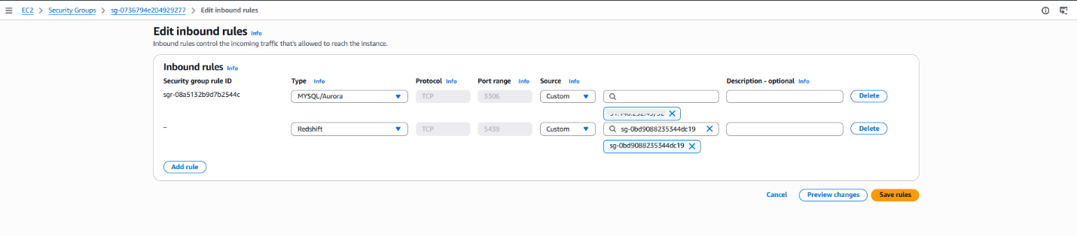
Since the default Lambda runtime does not include the Redshift Python connector library, a Lambda Layer needed to be built containing the required dependencies. AWS CloudShell was used to install the redshift_connector package and its dependencies, then package them into a redshift-layer.zip file. CloudShell was chosen over a local machine because it provides a preconfigured Linux environment matching Lambda's runtime, avoiding compatibility issues with compiled dependencies. Th following code was initiated:
mkdir -p python
pip install redshift-connector -t python/
zip -r redshift-layer.zip python
The resulting zip file was downloaded from CloudShell using its "Download file" feature:
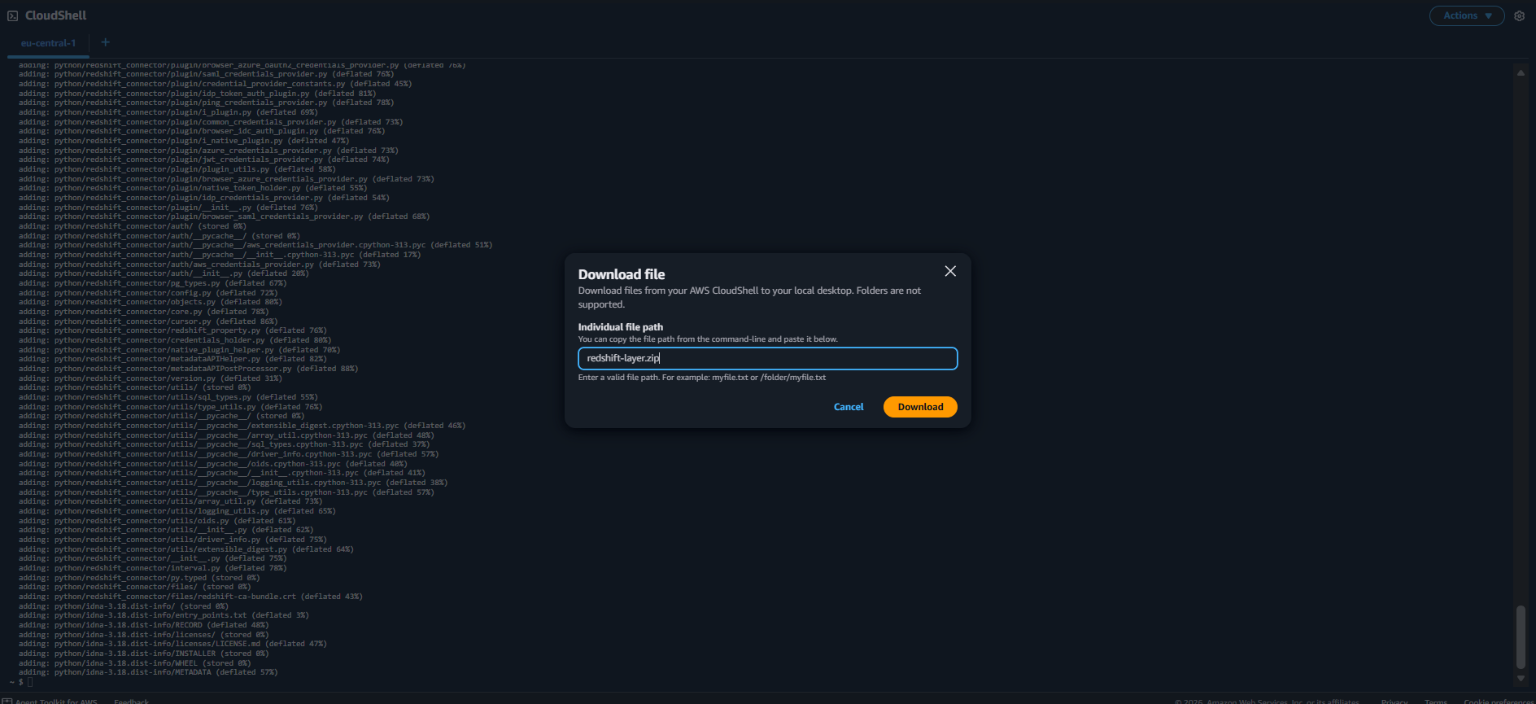
In the Lambda console, a new layer was created under Layers → Create layer, named redshift-connector-layer. The packaged redshift-layer.zip file was uploaded as the source code, and Python 3.14 was selected as the compatible runtime, matching the runtime used by the Lambda function itself. This step made the Redshift connector library available to any Lambda function that later attaches this layer, without needing to bundle the library directly into the function's own deployment package.
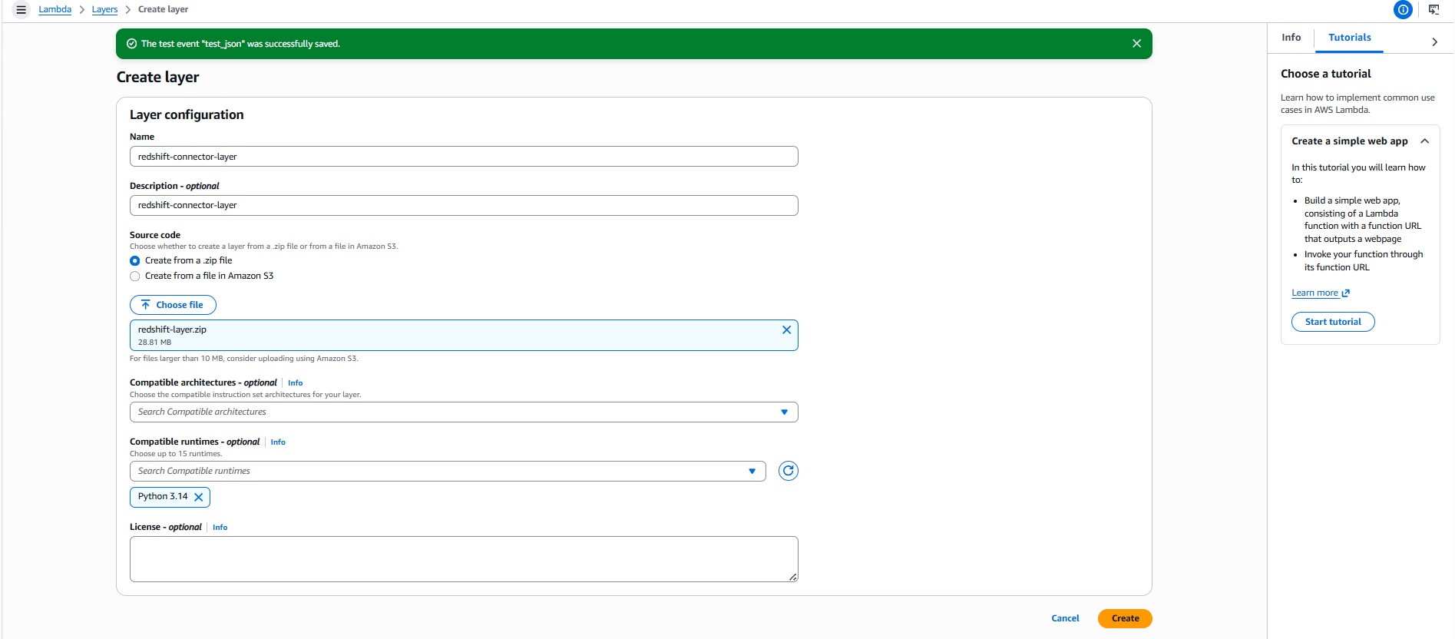
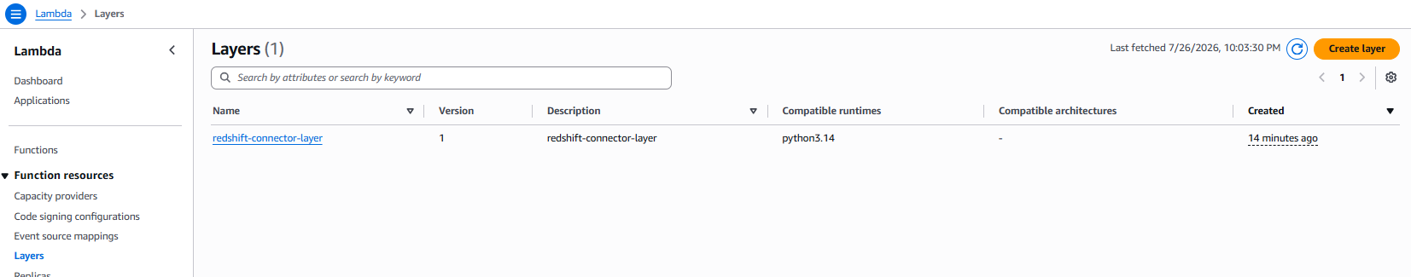
A dedicated IAM role named lambda-redshift-role was created for this function, with the description "Allows Lambda functions to call AWS services on your behalf." The trust policy was configured to allow the lambda.amazonaws.com service to assume this role, which is the standard trust relationship required for any Lambda execution role.
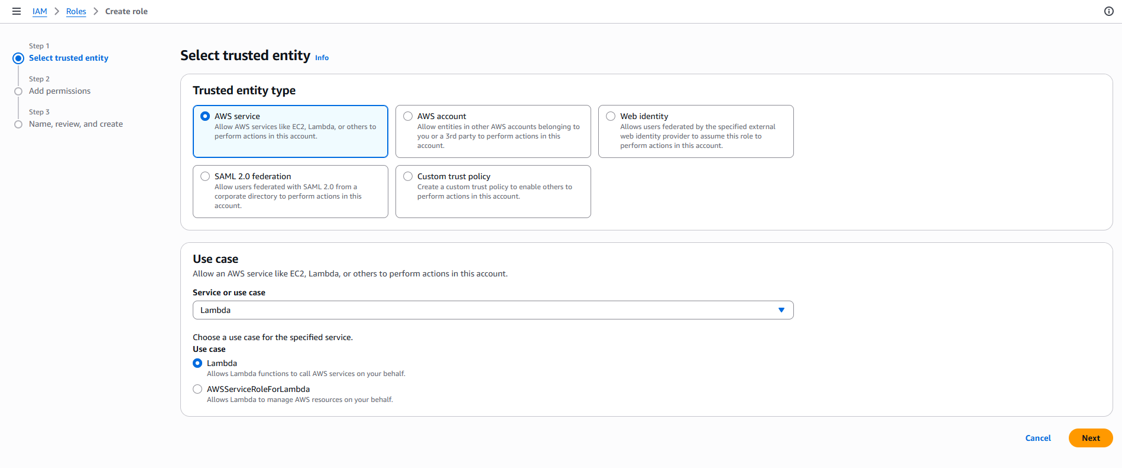
Two AWS managed policies were attached to this role: AWSLambdaBasicExecutionRole, which grants permission to write logs to CloudWatch, and AWSLambdaVPCAccessExecutionRole, which grants the permissions needed for a Lambda function to create and manage network interfaces inside a VPC. The second policy was specifically required because connecting Lambda to Redshift means placing the function inside a VPC, and without this policy the function would be unable to obtain the elastic network interfaces (ENIs) needed to communicate over that VPC's subnets.
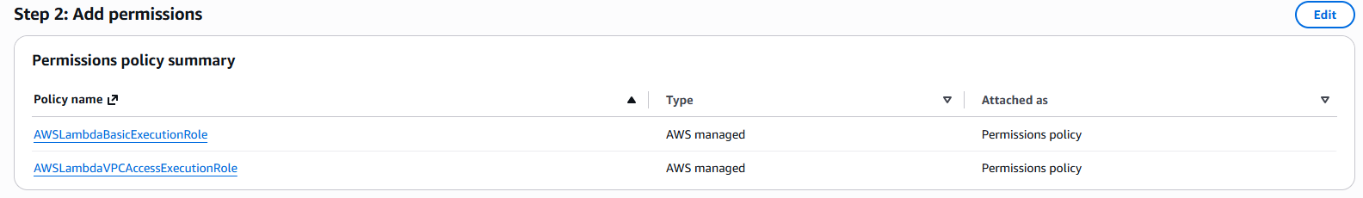
The IAM role as named lambda-redshift-role to be easily found and used.
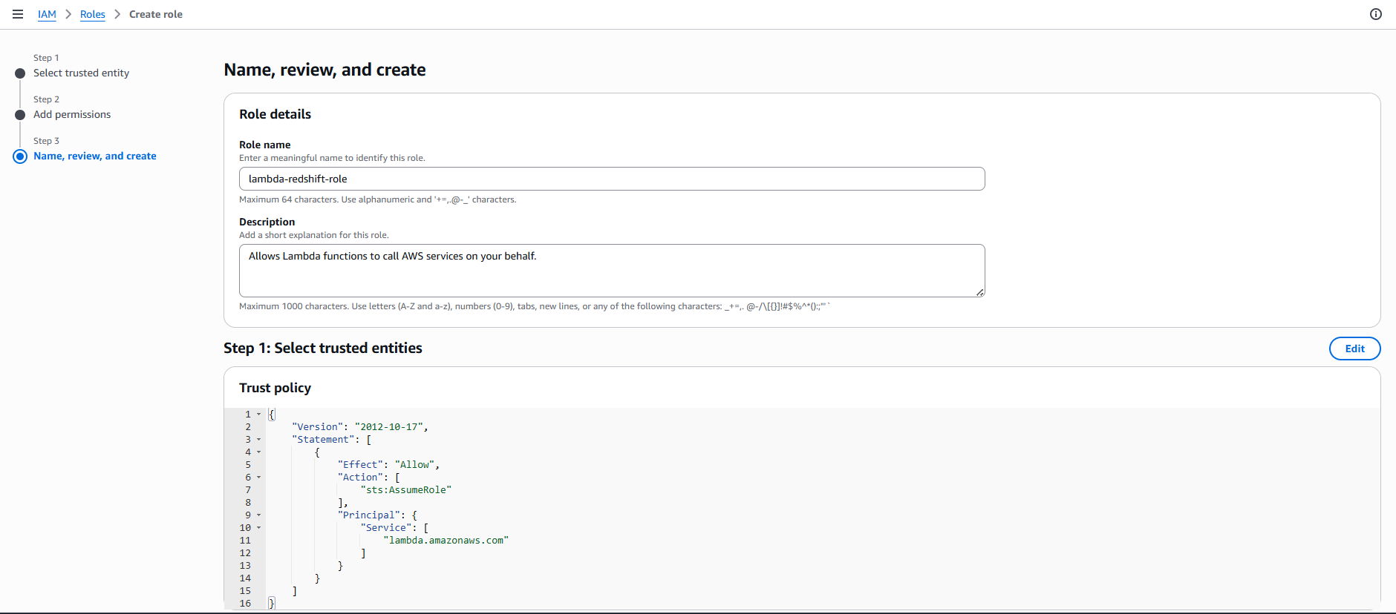
A new Lambda function named first-redshift-test was created using "Author from scratch" with the Python 3.14 runtime, consistent with the runtime used for both the layer and the connector library. Under the custom execution role setting, the previously created lambda-redshift-role was selected instead of letting Lambda generate a new default role, since this custom role already contained the specific permissions needed for CloudWatch logging and VPC access.
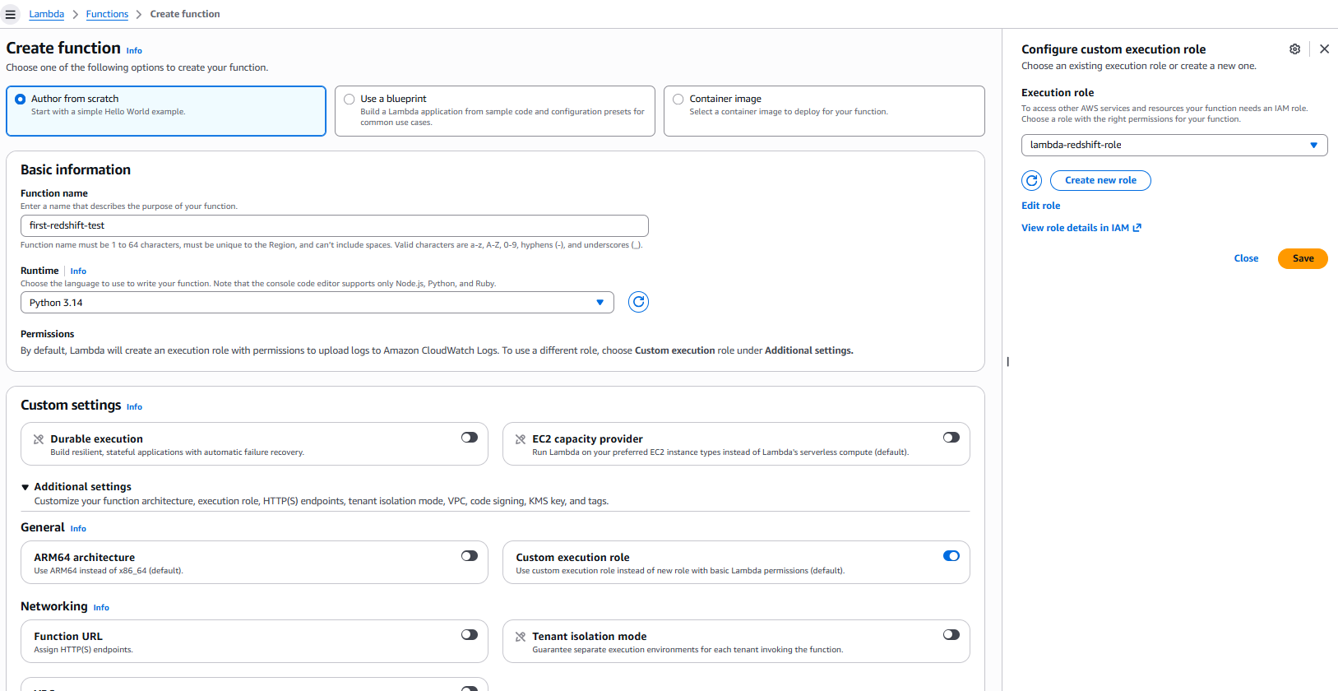
The redshift-connector-layer was added to the function by choosing "Custom layers" (rather than AWS-provided layers or a layer ARN) and selecting the layer and its version (version 1) from the dropdown. This step made the Redshift connector library available for import within the function's code without needing to upload it as part of the function package itself.
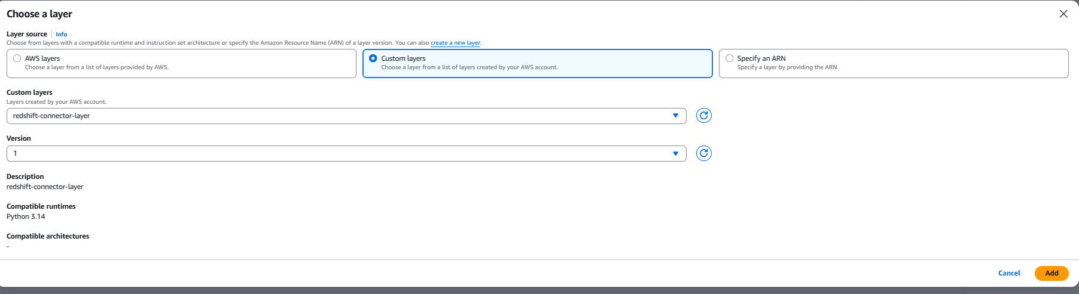
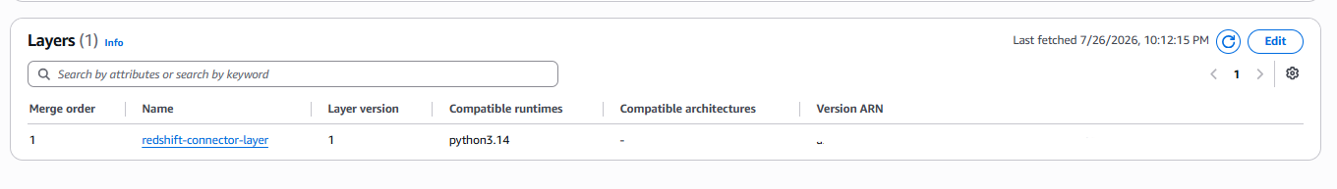
Under the function's VPC configuration, the same VPC used by the Redshift cluster (vpc-04521702e2480ec7b) was selected. Two subnets were chosen (subnet-071bb7bc77be6f49f in eu-central-1c and subnet-05ac98e00dab4315f in eu-central-1b), which allows Lambda to launch execution environments across multiple availability zones for redundancy. The lambda-redshift-sg security group created earlier was attached here as well, ensuring the function's network traffic is governed by the inbound/outbound rules defined specifically for Redshift access. A console warning noted that placing a function inside a VPC removes its default internet access unless routed through a NAT gateway, which is an expected trade-off since this function only needs to reach Redshift privately, not the public internet.
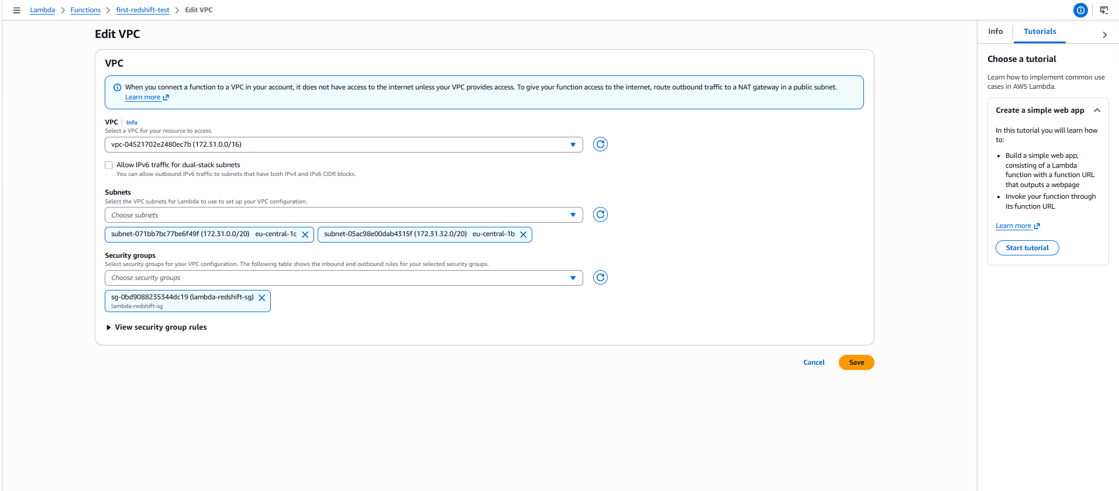
The function's timeout was increased from the default (a few seconds) to 30 seconds, since establishing a database connection and running a query inside a VPC typically takes longer than a simple, self-contained Lambda invocation, and a short timeout risked the function failing before the Redshift query could complete:
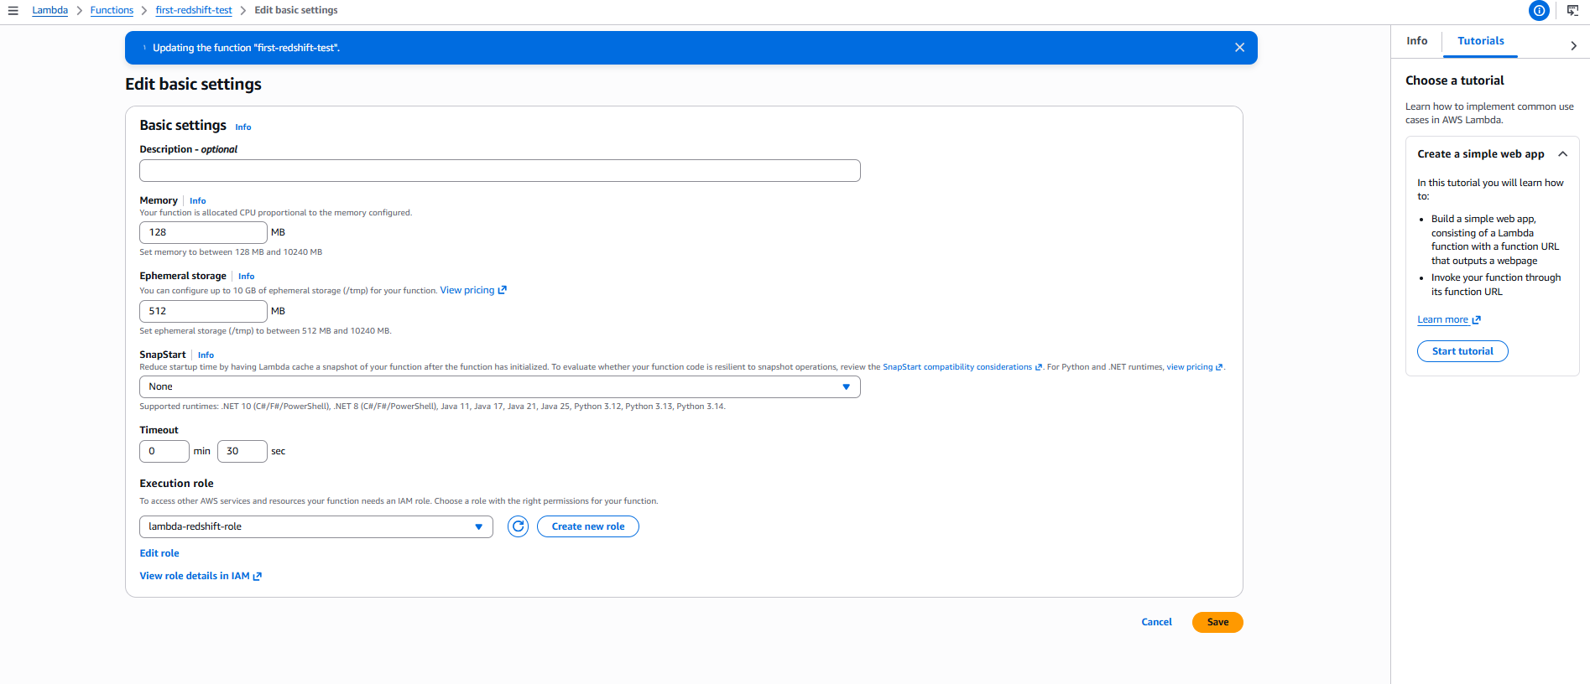
Four environment variables were added to the function: REDSHIFT_HOST, REDSHIFT_DB (set to dev), REDSHIFT_USER (set to admin), and REDSHIFT_PASSWORD. Storing these values as environment variables rather than hardcoding them into the function code keeps sensitive connection details out of the source code and makes it easy to update credentials or connection details without redeploying the function:
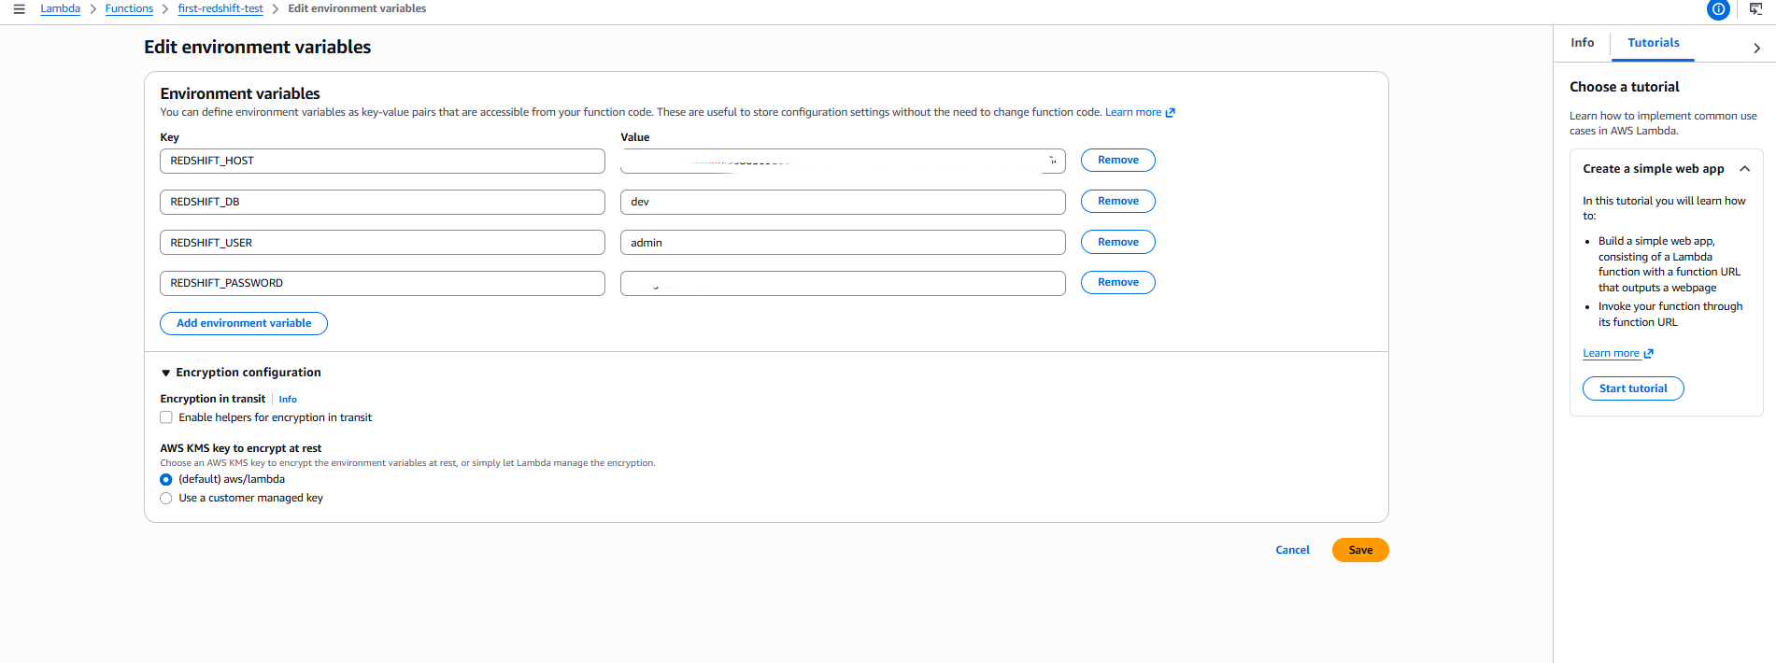
The first-redshift-test function was written to connect to Redshift using the redshift_connector library, with connection parameters (REDSHIFT_HOST, REDSHIFT_DB, REDSHIFT_USER, REDSHIFT_PASSWORD) pulled from environment variables rather than hardcoded, consistent with the earlier setup. Port 5439 was used explicitly, since that is the standard Redshift port and matches the security group rule configured earlier.
The function executes a single SQL query against user_dilab.dim_stores that returns three values in one pass: the total row count, the count of distinct store_surr_id values, and a count of rows where store_surr_id is null. Combining these into one query (rather than three separate queries) reduces the number of round trips to the database and keeps the connection open for less time.
Using these three values, a boolean test_passed is calculated as true only if there are zero null store_surr_id values and the total row count equals the distinct ID count — meaning there are no missing keys and no duplicate keys in the table. The function returns {"testPassed": test_passed}. Returning a simple boolean flag (rather than raw data) makes the function's result easy for a Step Function to branch on later using a Choice state.
The code:
import os
import redshift_connector
def lambda_handler(event, context):
conn = redshift_connector.connect(
host=os.environ['REDSHIFT_HOST'],
database=os.environ['REDSHIFT_DB'],
port=5439,
user=os.environ['REDSHIFT_USER'],
password=os.environ['REDSHIFT_PASSWORD']
)
cursor = conn.cursor()
cursor.execute("""
SELECT
COUNT(*) AS total_rows,
COUNT(DISTINCT store_surr_id) AS distinct_ids,
SUM(CASE WHEN store_surr_id IS NULL THEN 1 ELSE 0 END) AS null_ids
FROM user_dilab.dim_stores
""")
total_rows, distinct_ids, null_ids = cursor.fetchone()
conn.close()
test_passed = (null_ids == 0) and (total_rows == distinct_ids)
return {"testPassed": test_passed}
After deploying the function, a test event named test1 was created and run:
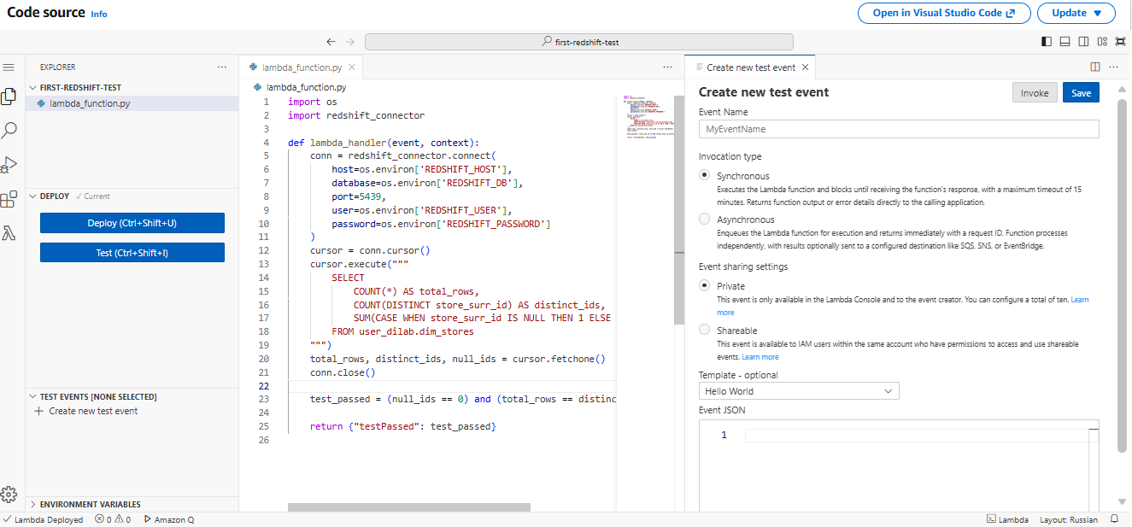
The execution succeeded with the response {"testPassed": true}, confirming the table passed the integrity check at this point, before any data changes were made. The Init Duration of 1097 ms visible in the logs reflects the cold-start time needed to import the redshift_connector library and establish a new connection.
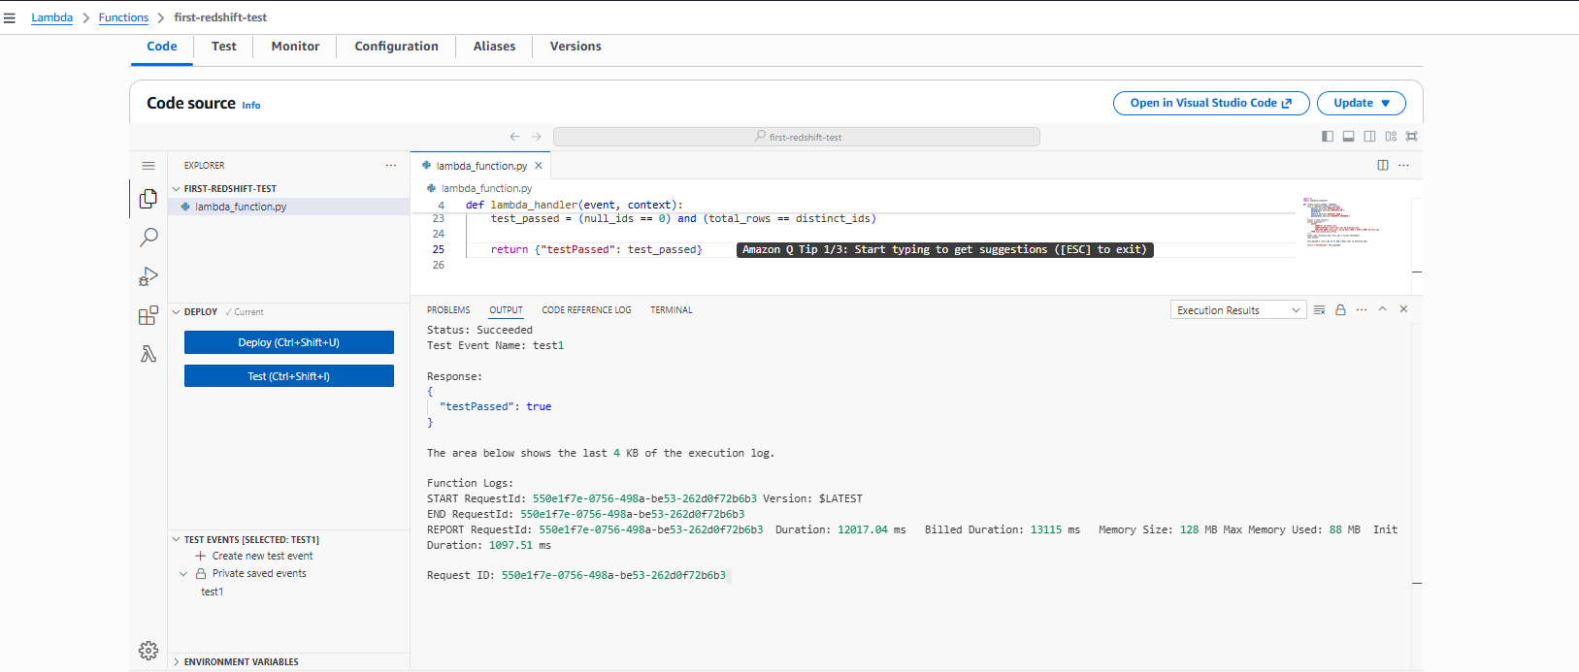
A second function, update-redshift-data, was created in the similar way as the first one- to simulate a data change on the same table between the two tests.
This function connects to Redshift the same way as the first function, then executes an UPDATE statement on user_dilab.dim_stores, setting the ta_update_dt column to CURRENT_DATE for the row where store_surr_id equals the minimum store_surr_id value in the table (found via a SELECT MIN(store_surr_id) subquery). Targeting the row with the minimum ID, rather than an arbitrary or hardcoded ID, ensures the update logic works regardless of the exact data present in the table and always affects exactly one deterministic row.
import os
import redshift_connector
from datetime import date
def lambda_handler(event, context):
conn = redshift_connector.connect(
host=os.environ['REDSHIFT_HOST'],
database=os.environ['REDSHIFT_DB'],
port=5439,
user=os.environ['REDSHIFT_USER'],
password=os.environ['REDSHIFT_PASSWORD']
)
cursor = conn.cursor()
cursor.execute("""
UPDATE user_dilab.dim_stores
SET ta_update_dt = CURRENT_DATE
WHERE store_surr_id = (SELECT MIN(store_surr_id) FROM user_dilab.dim_stores)
""")
conn.commit()
conn.close()
return {"status": "updated"}
An explicit conn.commit() call was included after the execute() call, since Redshift connections default to requiring an explicit commit for changes to persist — without this line, the update would be rolled back once the connection closed. The function returns {"status": "updated"} as a simple confirmation. After deploying, the test event update-redshift-data was run:

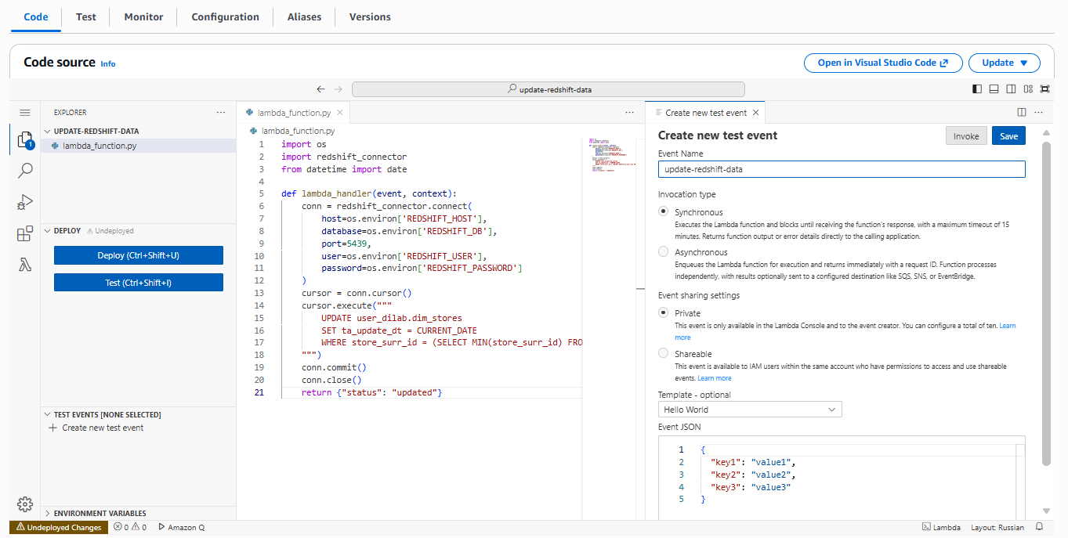
The function returned Status: Succeeded with the response {"status": "updated"}, confirming the row was modified:
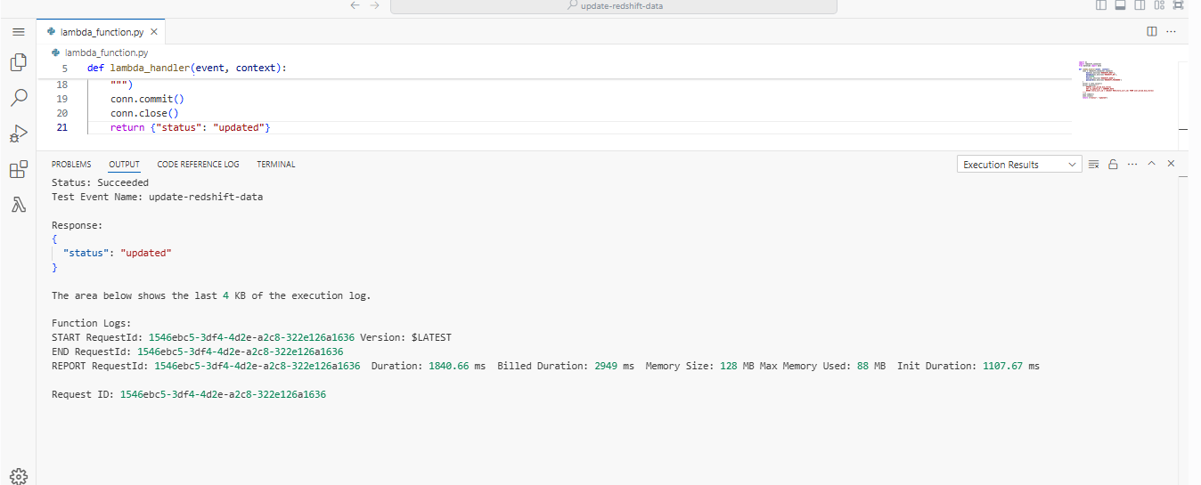
A third function, second-redshift-test, was created to verify that the update from the previous step actually took effect. Rather than repeating the same row-count/null-count check as the first test (which wouldn't detect this particular kind of update, since it doesn't change row counts), this function specifically queries the ta_update_dt value for the same row that was just updated (the row with the minimum store_surr_id), using the same SELECT MIN(store_surr_id) subquery pattern to guarantee it checks the identical row that update-redshift-data modified:
import os
import redshift_connector
from datetime import date
def lambda_handler(event, context):
conn = redshift_connector.connect(
host=os.environ['REDSHIFT_HOST'],
database=os.environ['REDSHIFT_DB'],
port=5439,
user=os.environ['REDSHIFT_USER'],
password=os.environ['REDSHIFT_PASSWORD']
)
cursor = conn.cursor()
cursor.execute("""
SELECT ta_update_dt
FROM user_dilab.dim_stores
WHERE store_surr_id = (SELECT MIN(store_surr_id) FROM user_dilab.dim_stores)
""")
result = cursor.fetchone()[0]
conn.close()
test_passed = (result == date.today())
return {"testPassed": test_passed}
The function compares the retrieved ta_update_dt to date.today() (imported from Python's datetime module), setting test_passed = (result == date.today()). This directly validates that the update Lambda successfully set the date to today's date, rather than just re-running a generic integrity check — giving a more meaningful "before vs after" comparison for the Step Function pipeline. The function returns {"testPassed": test_passed}, using the same response shape as the first test function so that both can be evaluated identically inside the Step Function's Choice state later.
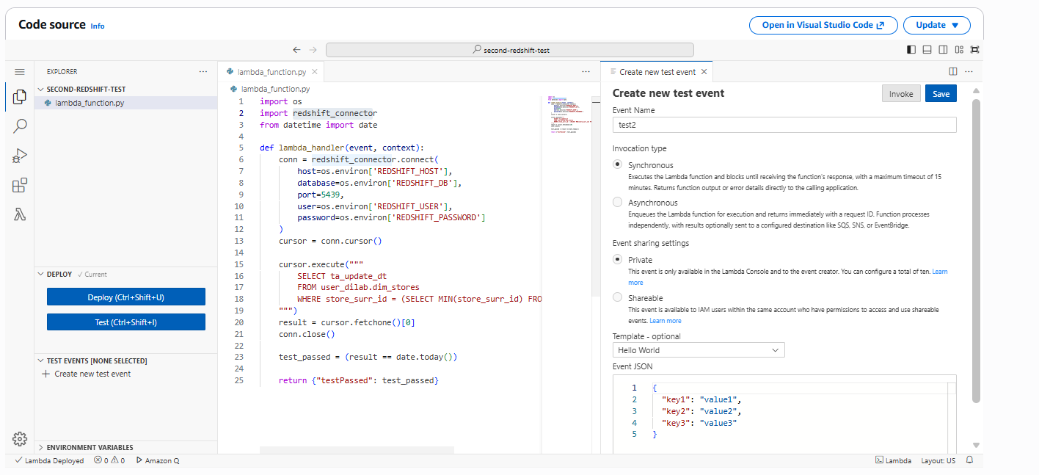
After deploying, the test event test2 was run and succeeded, returning {"testPassed": true}, confirming the second test correctly detected that the row had been updated to today's date.
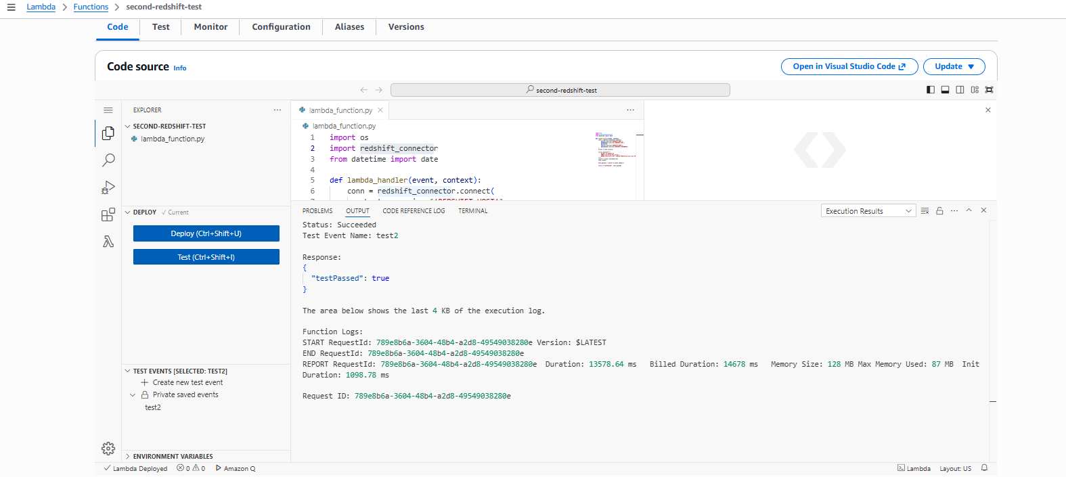
A new state machine named step_function was created in AWS Step Functions. The Express type was selected instead of Standard, since Express workflows are designed for short-lived, high-frequency workflows with a maximum runtime of five minutes and are lower cost, which matched this use case well — a linear sequence of quick Lambda invocations with no need for long-running durability or the one-year execution history that Standard workflows provide. History for Express workflows is instead streamed to CloudWatch Logs.

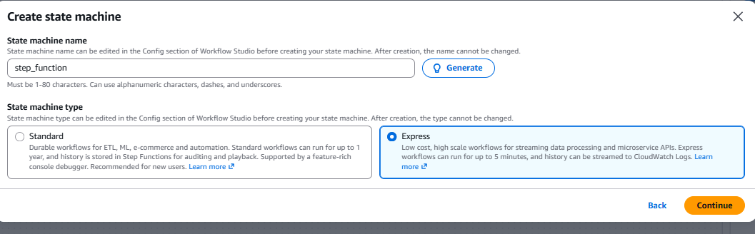
The state machine was built using the Workflow Studio code editor, defining the following sequence of states:
FirstRedshiftTest — a Task state that invokes the first-redshift-test Lambda function. Its result is stored under FirstTestResult, and the flow proceeds to UpdateRedshiftData.
UpdateRedshiftData — a Task state that invokes the update-redshift-data Lambda function, storing its result under UpdateResult, then proceeds to SecondRedshiftTest.
SecondRedshiftTest — a Task state that invokes the second-redshift-test Lambda function, storing its result under SecondTestResult, then proceeds to CheckBothTests.
CheckBothTests — a Choice state that evaluates whether both $.FirstTest.testPassed and $.SecondTest.testPassed are equal to true. If both conditions are satisfied, the flow transitions to BothTestsPassed; otherwise, it falls through to the Default branch, SomeTestsFailed.
BothTestsPassed — a Succeed state, marking the overall Step Function execution as successful.
SomeTestsFailed — a Fail state, with an error of "TestsFailed" and a cause describing that one or both Redshift tests failed.
The code:
{
"Comment": "Redshift test-update-test workflow",
"StartAt": "FirstRedshiftTest",
"States": {
"FirstRedshiftTest": {
"Type": "Task",
"Resource": "arn:aws:lambda:eu-central-…….:function:first-redshift-test",
"ResultPath": "$.firstTest",
"Next": "UpdateRedshiftData"
},
"UpdateRedshiftData": {
"Type": "Task",
"Resource": "arn:aws:lambda:eu-central-1:………:function:update-redshift-data",
"ResultPath": "$.updateResult",
"Next": "SecondRedshiftTest"
},
"SecondRedshiftTest": {
"Type": "Task",
"Resource": "arn:aws:lambda:eu-central-1:………..:function:second-redshift-test",
"ResultPath": "$.secondTest",
"Next": "CheckBothTests"
},
"CheckBothTests": {
"Type": "Choice",
"Choices": [
{
"And": [
{
"Variable": "$.firstTest.testPassed",
"BooleanEquals": true
},
{
"Variable": "$.secondTest.testPassed",
"BooleanEquals": true
}
],
"Next": "BothTestsPassed"
}
],
"Default": "SomeTestsFailed"
},
"BothTestsPassed": {
"Type": "Succeed"
},
"SomeTestsFailed": {
"Type": "Fail",
"Error": "TestFailed",
"Cause": "One or both Redshift tests failed"
}
}
}
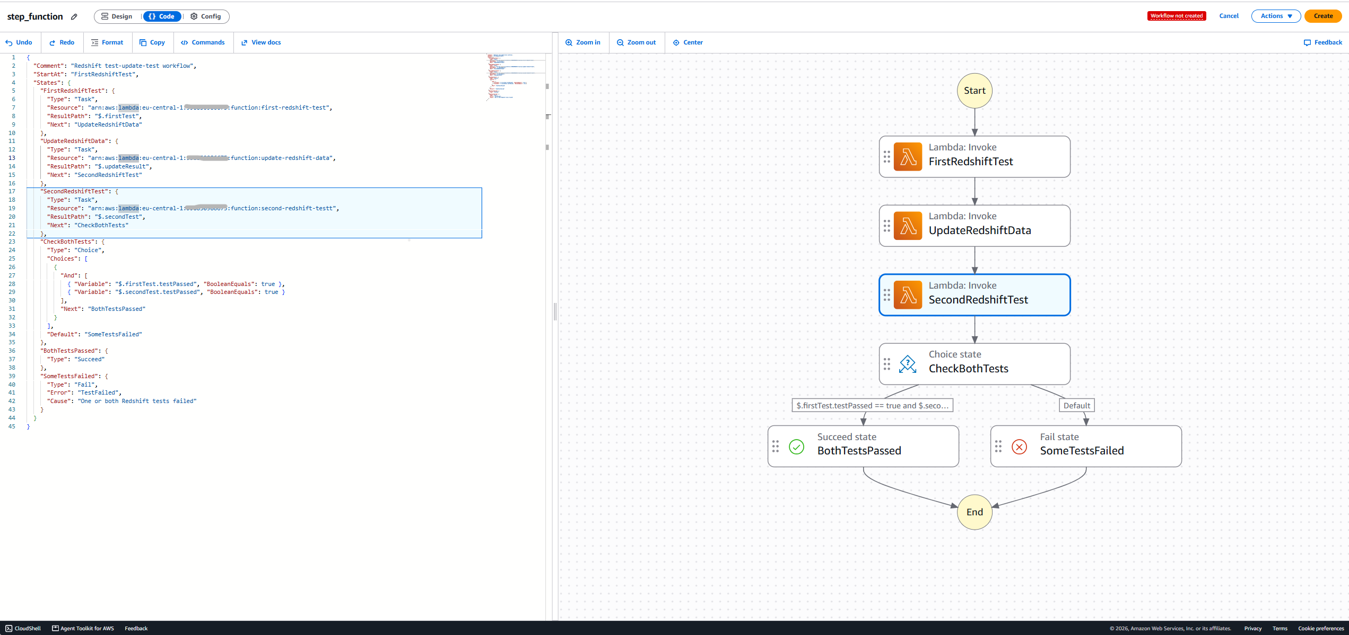
The state machine was started with the "Start execution" action, using the asynchronous execution type (the default), which returns confirmation that the workflow started without blocking on its completion — appropriate here since the workflow only takes a few seconds and results could be reviewed afterward in the console rather than needing to wait synchronously. An empty/default JSON input was used since none of the Lambda functions in this workflow required external input data — all connection parameters were already sourced from environment variables, and the row targeted for update was determined dynamically via the SELECT MIN(store_surr_id) query rather than passed in as input.
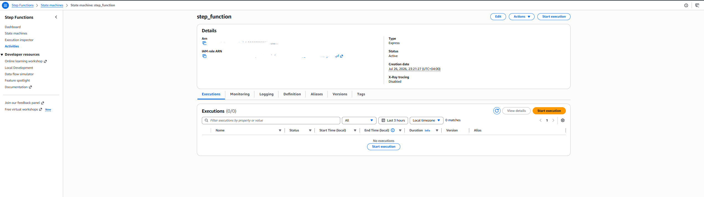
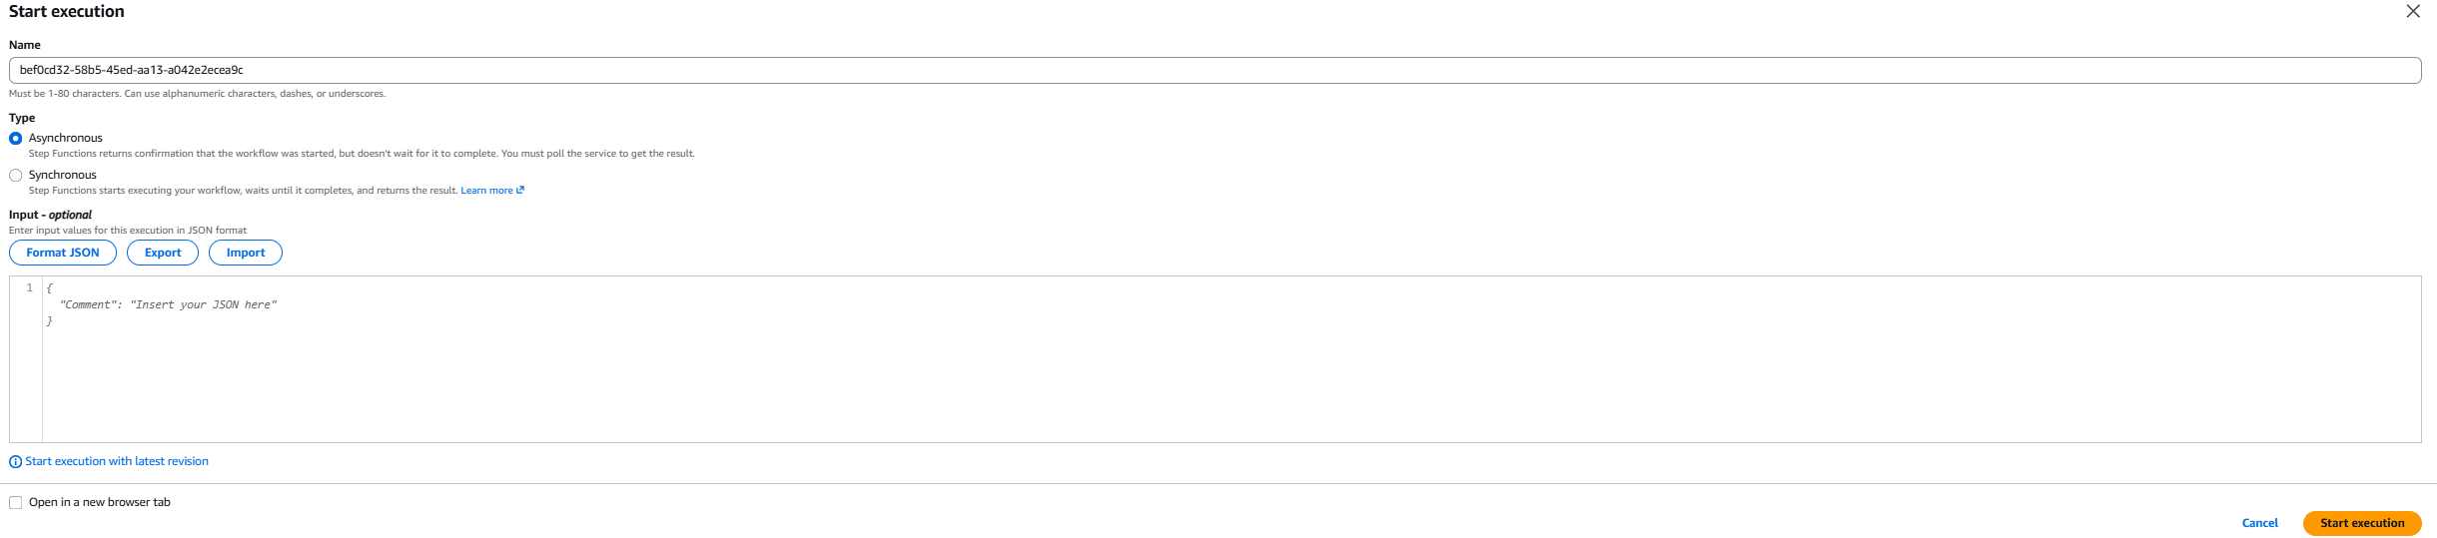
The execution completed successfully with an overall status of "Succeeded" and a total duration of about 3.8 seconds. The Graph view confirmed the expected path was taken: FirstRedshiftTest → UpdateRedshiftData → SecondRedshiftTest → CheckBothTests → BothTestsPassed, with every individual state highlighted in green as succeeded.
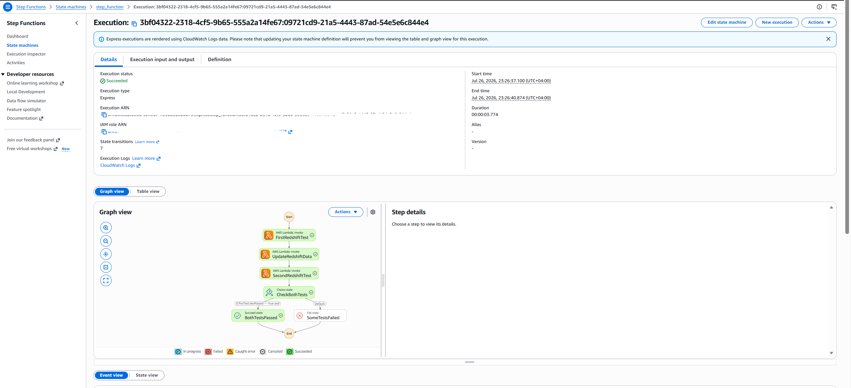
The Table view of the execution broke down the duration of each step individually: FirstRedshiftTest completed in roughly 0.5 seconds, UpdateRedshiftData in about 0.9 seconds, and SecondRedshiftTest in about 2.4 seconds (the longest step, consistent with it needing to query and compare a date value). Each Task state also linked directly to its corresponding Lambda execution logs and log group, allowing individual verification of what happened inside each Lambda invocation as part of this single Step Function run.
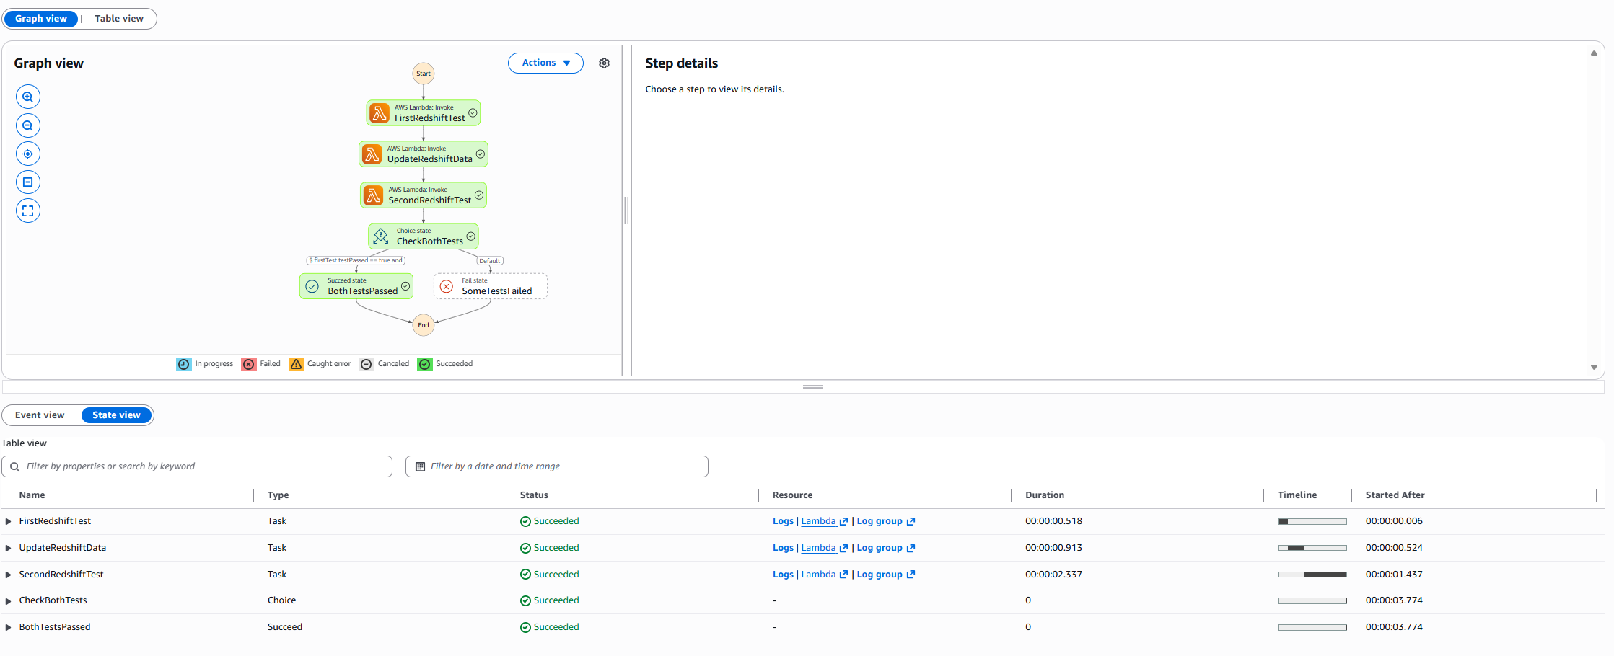
Conclusion
The complete workflow required by the task was successfully implemented and verified end-to-end: a Step Function state machine was created that first tests the Redshift table, then modifies a row in it, then re-tests the table, and finally succeeds only if both the first and third steps (the two tests) passed — matching exactly the logic outlined in the task requirements. The successful execution, with all four Lambda-related steps and the Choice state resolving to BothTestsPassed, confirms the entire pipeline — from Lambda-to-Redshift connectivity through networking (Layer, VPC, subnets, security group) to the orchestration logic in Step Functions — works correctly as a whole.
After completing all lab tasks , all AWS services used in lab were terminated.

